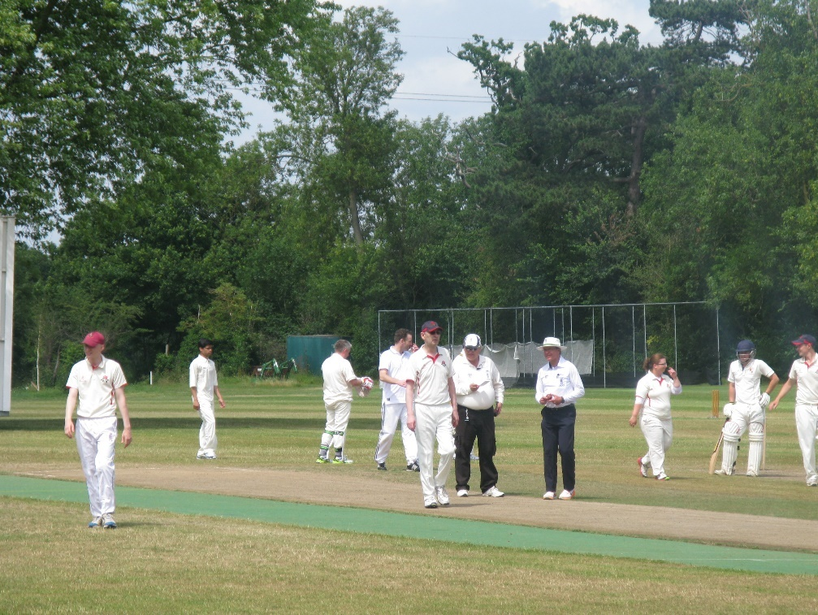

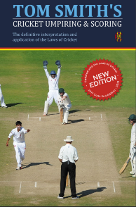
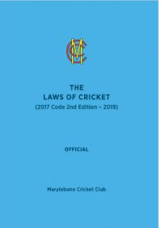
This document is primarily, but not exclusively, intended for use by those in the accreditation programme towards their U2A.
It is not a mandatory part of the programme but is considered a helpful aid as it contains many real-life scenarios that have been encountered by your colleagues over many years.
The intention is that each of the scenarios can be worked through on your own or with your colleagues or your mentor.
Reference should be made to the latest edition of the MCC Laws of Cricket, Tom Smiths and your appropriate competition regulations.
The rear section of this booklet contains some useful information sheets and links to various CPD modules that will enhance your experience.
Thanks to the significant contributions from:
Ian Royle REO South Central Region & CDO Oxfordshire
Keith Parsons RDO East Midlands
Editor
John Golding RDO South Central Region & CDO Berkshire

Use the lower box to enter your answer and any comments (max 2250 characters)
Scenario 2.1
You are the bowlers end umpire and as the ball is delivered you notice the wicketkeeper has “accidentally” nudged the bails off.
The ball goes on to hit the stumps.
Your decision is?
And why?

Click or tap here to enter text.

Use the lower box to enter your answer and any comments (max 2250 characters)
Scenario 2.2
What do you understand by Law 4.2.1 All balls to be used in the match, having been determined by the umpires, shall be in the possession of the umpires before the toss and shall remain under their control throughout the match?
and
4.2.2 The umpire shall take possession of the ball in use at the fall of each wicket, at the start of any interval and at any interruption of play.
What does All the balls to be used in the match mean in practice?
Click or tap here to enter text.

Use the lower box to enter your answer and any comments (max 2250 characters)
Scenario 2.3
The light starts to fade which concerns you and your colleague.
There are only 5 overs left and a result in sight.
Do you suggest to the fielding captain that if he uses slow bowlers it is OK for play to continue?

Click or tap here to enter text.

Use the lower box to enter your answer and any comments (max 2250 characters)
Scenario 2.4
What would you do / have you done?
- What if a colleague is late arriving at the ground?
- What problems did you encounter in previous seasons during the hot, dry spells?
How did you deal with any problems?

Click or tap here to enter text.

Use the lower box to enter your answer and any comments (max 2250 characters)
Scenario 2.5
At the end of the first over and when the ball is dead, the opening batsmen meet in the middle to have their ‘chat’. Both batsmen are standing on the cut strip. What action, if any, do you take?
A short while later one of the opening batsmen is seen running on the pitch – what action, if any do you take?
One of the batsmen is taking guard about 3-4 feet in front of the popping crease. What advice do you offer to him and/or what action will you take?

Click or tap here to enter text.

Use the lower box to enter your answer and any comments (max 2250 characters)
Scenario 2.6
You have an appeal for “Hit Ball Twice” – what do you need to take into consideration before answering the appeal?

Click or tap here to enter text.

Use the lower box to enter your answer and any comments (max 2250 characters)
Scenario 2.7
You are the bowlers end umpire and you notice the bowler running into the protected area.
How many times should you allow this before you No Ball him?
Upon reflection are you about to make the correct decision?

Click or tap here to enter text.

Use the lower box to enter your answer and any comments (max 2250 characters)
Scenario 2.8
What has or may have affected your concentration during a game?
How do you deal with a loss of concentration?

Click or tap here to enter text.

Use the lower box to enter your answer and any comments (max 2250 characters)
Scenario 2.9
During the early part of the second innings, you notice that one of the batsmen, when they are the non-striker, is progressively backing up further and further out of their crease.
If the bowler attempts a Run Out what will you need to consider in making your decision?
What happens if the bowler attempts a Run Out but misses the stumps?

Click or tap here to enter text.

Use the lower box to enter your answer and any comments (max 2250 characters)
Scenario 2.10
An initial inspection of the ground reveals no problems.
You do not spot that the sight screens are set for a different pitch to the one being used.
No mention is made of this at the toss which the away team wins.
The away team bat their entire innings without mentioning the sight screens.
The opening bat of the home team asks for the sight screens to be moved. What now?

Click or tap here to enter text.

Use the lower box to enter your answer and any comments (max 2250 characters)
Scenario 2.11
Batsman is run out completing a second run, which ends the innings. His first run was “short”.
What is the action for the umpires?

Click or tap here to enter text.

Use the lower box to enter your answer and any comments (max 2250 characters)
Scenario 2.12
List and describe the Dead Ball situations that have actually occurred in your matches so far this season to develop a grid of the most common in practice.

Click or tap here to enter text.

Use the lower box to enter your answer and any comments (max 2250 characters)
Scenario 2.13
A fair delivery deflects off the striker's leg towards short fine leg.
The non-striker calls wait as a fielder moves towards the ball. The bowler turns to you (at bowler's end) - 'was that a shot UMPS?'.
Meanwhile, the fielder has picked up the ball and flicked it clumsily, straight into a helmet placed on the ground behind the keeper.
What is the action for the umpires?

Click or tap here to enter text.

Use the lower box to enter your answer and any comments (max 2250 characters)
Scenario 2.14
There is a clear disciplinary breach that should be reported as at least Level 1 and probably Level 2.
At the end of the match the player accuses the umpire involved of having aggravated his dissent by having appeared to be overly friendly with the opposition fielders.
In the face of this counter accusation, the umpire agrees not to proceed with any report, without discussing with you, his colleague….
What would you do?

Click or tap here to enter text.

Use the lower box to enter your answer and any comments (max 2250 characters)
Scenario 2.15
You see the ball apparently bounce over the boundary, and signal 4. The batsmen stop running, but the fielder throws the ball in and is adamant that the ball hit a divot inside the field of play and never reached the rope. What do you do?
A non-umpiring colleague who happens to be on the boundary signals to you that the fielder is correct. Does this change your mind?

Click or tap here to enter text.

Use the lower box to enter your answer and any comments (max 2250 characters)
Scenario 2.16
The batsman takes guard just outside the crease. As the bowler runs up they walk several feet down the pitch into the protected area, and hits the bowler back over their head for six. As striker’s end umpire, what action do you take?
The next ball the batsman does the same thing. It seems clear that they are going to do it every ball. Same question…

Click or tap here to enter text.

Use the lower box to enter your answer and any comments (max 2250 characters)
Scenario 2.17
Explain how you would go about a situation where you felt your colleague had made an error in a decision re interpretation of Law / Regulations.
i.e.
Colleague gives a run out decision, but you feel the wicket was broken by the fielder before the ball arrived.
or
Free hit given for beamer when regulations say only for foot faults

Click or tap here to enter text.

Use the lower box to enter your answer and any comments (max 2250 characters)
Scenario 2.18
The ball is hit towards the boundary, and the fielder dives to stop it. They throw the ball in and the batsmen run a single. Your colleague signals to you that the fielder was in contact with both ball and rope and that 4 runs should be awarded.
The fielding captain is incensed and demands that you ask the fielder and take their word for what happened. How do you respond?

Click or tap here to enter text.

Use the lower box to enter your answer and any comments (max 2250 characters)
Scenario 2.19
Your colleague comes to consult with you and is certain the scoreboard (up to now quite reliable) is incorrect by several runs. You suggest checking with the scorers at the next convenient point, but your colleague decides it needs checking and goes off to the scorers’ hut.
The players sit around asking ‘come on umps, what’s the hold up, can’t we just get on with it’. How do you respond?

Click or tap here to enter text.

Use the lower box to enter your answer and any comments (max 2250 characters)
Scenario 2.20
You are umpiring a club’s 3rd team limited over match which started at 1pm on the adjacent ground to the 1st team who are playing in a Premier league timed game. Their match started at 11:30am.
The time is now 2:30pm and you see the 1st team captain running towards your ground shouting at you demanding a player be released from the 3rd team as one of the 1st team has just become injured.
What do you do and how do you answer him?

Click or tap here to enter text.

The following pages contain some handouts that may be of use to you.

To help you develop there are a series of online CPD Modules that have been developed by the ACO and various Counties. They are readily accessible by all.
See:
South Central Region CPD Modules

Lancashire ACO CPD Modules
Middlesex ACO Preparation

The Spirit of Cricket
Cricket owes much of its appeal and enjoyment to the fact that it should be played not only according to the Laws but also within the Spirit of Cricket. The major responsibility for ensuring fair play rests with the captains, but extends to all players, match officials and, especially in junior cricket, teachers, coaches, and parents.
Respect is central to the Spirit of Cricket.
Respect your captain, teammates, opponents, and the authority of the umpires.
Play hard and play fair.
Accept the umpire’s decision.
Create a positive atmosphere by your own conduct and encourage others to do likewise.
Show self-discipline, even when things go against you.
Congratulate the opposition on their successes and enjoy those of your own team.
Thank the officials and your opposition at the end of the match, whatever the result.
Cricket is an exciting game that encourages leadership, friendship, and teamwork, which brings together people from different nationalities, cultures and religions, especially when played within the Spirit of Cricket.

Pre-match activity

Arrive at the ground at least 45 minutes before the scheduled start time:
- Report to the Ground Executive
- Meet your colleague, scorers, and the groundsman if available.
- Obtain the match balls and spares.

Together with your colleague tour the ground:
- Check the boundary and how it is marked.
- Ensure pitch markings are correct and wickets are pitched correctly.
- Check for trees and other obstacles close to or on the field of play.
- Check positions of sightscreens (and room to move them)

Check with Groundsman.
- Availability of sawdust and provision of covers

Meet with Captains (pre-toss discussion)
- Receive completed team sheets and check they are signed.
- Hours of play
- Intervals – timing and duration
- Drinks interval(s) - timing
- Boundaries and allowances
- Any local customs
- Competition regulations e.g., bowling restrictions
- Number and taking of new balls in the match.
- Display of the score and overs.
- Clock and watch to be master timepiece and backup.
- Confirm use of covers during the match.
- Supervise the toss - (post-toss discussion)
- Result of toss and winning captain’s intentions immediately after the toss.

Pre-match activity (cont.)

Confirm with Scorers.
- Team sheets if necessary
- Hours of play
- Intervals – timing and duration
- Drinks interval(s) – the timing
- Boundary allowances
- Any local customs — boundaries
- Competition regulations e.g., bowling restrictions
- Number and taking of new balls in the match.
- Display of the score and overs.
- Clock and watch to be master timepiece and backup.
- Acknowledgement of signals
- Other signals to be used including any pre-signals.
- Where they will be sitting during the match
- The result of the toss
- Any other relevant points

The FIVE Minute Drill

- Ring bell or call ‘5 mins’ to teams
- Proceed to the pitch 5 minutes before ‘Play.’
- Confirm field of play clear of obstacles i.e., Training Kit.
- Recheck wicket alignment and build.
- Ascertain opening end.
- Confirm the correct number of players.
- Find out the Bowler’s action and so inform the striker.
- If required, give the marker to the bowler.
- Give guard to the striker.
- Confirm accurate sight screen placement.
- Pass the match ball to the bowler.

- Conduct the following checks in a suitable order:
  - The fielding captain is ready.
  - That striker is ready.
  - That the scorers are ready
  - That the other umpire is ready and the time to start has been reached

- Call Play

Positioning

The umpires shall stand where they can best see any act upon which their decision may be required.

Bowler’s End.

Prior to delivery
The umpire should stand in a direct line behind wicket to wicket. Although all umpires will claim they do this it is not always the case and umpires should check their position with their colleague at the time of making the wicket prior to the call of “Play”.

The umpire must be in a position where he is able to see:
1 the landing of the back foot
2 the landing of the front foot
And
pick up the flight of the ball all without moving his head.

Should the bowler ask the umpire to stand closer to, or further back from, the wicket then the umpire should comply with this request providing he is not prevented from seeing the feet and the ball as above.

Positioning (cont.)

Batsmen attempting runs.
The umpire must always watch the ball and have his head stationary and his eyes level at the instant of any decision he is called upon to make. This is crucial whether moving into a position to judge a Run Out or when judging a hard straight shot which is deflected by the bowler and does not give sufficient time for umpire movement.

When the umpire moves into a position to judge a Run Out he must still follow Law 3.11 and always watch the ball for as long as is necessary to stay safe. The side to which he moves will vary and there are several theories around this and some examples are given below but the bottom line is, it is more important to be safe than to be in the textbook position to give a decision:

- Ball hit towards third man; umpire should move with the ball to a position square on the off-side from which he can see the ball, the fielder, the running batsmen (to confirm the completion of each run) and the breaking of the wicket at both ends.

- Ball hit towards square leg; umpire should again follow the ball his eyes but this time he will move to the leg-side from where he can see all the relevant points from a) above.

- Ball is hit to mid-off; the umpire will follow the ball with his eyes. At the same time, he should rotate his hips to keep facing the ball. This rotation of his hips, together with the decision to move quickly, will initiate the moving his body naturally to the leg side. From this side he will still be able to observe the ball, the fielder, the running batsmen and any breaking of the wicket whilst being in a position safe from being hit by any throw or interfering with any fielder.

- Ball hit to long off; the umpire may choose to move to the off-side providing he has sufficient time not to impede any throw by the fielder at either wicket. He must watch the ball and remain safe at all times.

Positioning (cont.)

Positioning - Striker’s End

Normally the umpire should stand at square leg in line with the popping crease at the striker’s end. He may, however, choose to stand on the off-side when:

- A fielder’s position prevents him seeing the striker’s popping crease and/ or wicket

- He needs to have a better view of the number of fielders behind the popping crease on the leg-side

- The sun is shining or is reflected in his eyes

- He cannot see the popping crease because of the sun or a sloping ground

- He wishes to observe a bowler’s action from a different perspective

- A runner is acting for an injured player

If he does choose to stand on the off-side for any of the reasons he must inform his colleague, the fielding captain and the batsmen.

The umpire’s distance from the wicket will depend on a number of factors (e.g. position of fielders, restriction of fielders imposed by fielding circles) but he must stand where he can best see any act upon which his decision may be required. The umpire must be careful not to stand too deep. He should never be more than 30 yards from the striker’s wicket.

He must keep out of the way of the fielders and always watch the ball and the running batsmen e.g.:

- Ball hit to fine-leg; umpire adjusts his stance to face third man from where he can follow the running batsmen, the fielder and the ball using the “tennis umpire” approach.

- Ball hit to mid-wicket: umpire adjusts to face long-off from where he can follow the action as in a) above.

- Ball hit to square-leg: umpire turns 90 degrees to be parallel to the popping crease from where he can follow the action as in a) above and avoid being hit by any throw.

In all cases, whether at bowler’s end or striker’s end, the umpire must be able to follow the action and remain safe.

Positioning (cont.)

Positioning with a Runner

When a runner is acting for an injured player Law 2.9 still applies and the umpires shall stand where they can best see any act upon which their decision may be required.

Both umpires must always watch the ball and have their heads stationary and their eyes level at the instant of any decision they are called upon to make.

Bowler’s End

Prior to delivery
The guidance given on page 27 still applies.

Batsmen attempting runs.
If the fit batsman is on strike, then the guidance given on page 27 still applies and the injured striker is irrelevant.

If the injured player is on strike, then the bowler’s end umpire must always move to the side on which his colleague at striker’s end is standing. This will always apply even if the ball is hit square of the bowler’s wicket (i.e., mid-off or mid-on) on that side. The umpire must watch the running batsmen (including the runner), the fielder and the ball using the “tennis umpire” approach.

Striker’s End

When the fit batsman is on strike the injured player is completely out of the game unless he obstructs the field (Law 37). The umpire should stand in his preferred position, usually on the leg side (see page 27), and the injured player should stand behind him.

When the injured player is on strike the umpire must stand on the opposite side to the runner in order that he can watch the injured player, non-striker and runner. Which side he chooses will depend on many factors including the crease markings on the square, so that he can be certain of the injured striker’s ground and the position of the fielders so that neither they, nor the runner, impede each other.

In all case, whether at bowler’s end or striker’s end, the umpire must be able to follow the action and remain safe.

Guidelines for Players who Umpire and/or Score.
These guidelines are provided to help ensure that ECB and League regulations are consistently applied in both innings. They should be discussed with the Standing Umpire(s) prior to the toss.

Players who Umpire at the Strikers End
To maximise the match experience, it is recommended that experienced players who know the laws of the game assist the standing umpire by standing at the striker’s end.
The Player is an Umpire and a Partner of the Standing Umpire and is:
- Responsible for stumping and run out decisions (the line needs to be visible to make sure of the grounding behind it).
- Ensuring the stumps and bails are correctly set after the wicket is broken.
- Confirming catches in the field and whether the players crossed before the catch.
- Confirming the ball reaches the boundary bouncing or on the full.
- Counting the valid deliveries in the over and acknowledgement of balls to go signals from the bowler’s end umpire. (Signals are usually made with 2 balls to go in the over)
- Advising of any short runs.
- Advising of any deliveries that pass the batsman on the full above waist height in a standing position.
(the pace of the bowler is not relevant, and the waist is the belly button above the top of the trousers).
- Advising of any delivery that bounces above head height of the batsman in a standing position.
- Confirming the number of completed runs before the ball is dead or if thrown over the boundary by a fielder (the standing umpire will consult in these situations).
- Call No Ball when the fielding side has more than two fielders behind square on the leg side or other fielding restriction violations depending on regulations for the match.
- The standing umpire may consult on other issues during the game.

Guidelines for Players who Umpire and/or Score (cont.)

Players who Score.
The scorers are responsible the scores, which must be a minimum of the runs scored, wickets taken, and overs bowled. The umpires will want to be certain that all of their signals have been received so all signals must be acknowledged by a wave or other agreed method and correctly recorded in the score book.
The umpires do not keep score.
- Update the scorebook every ball and acknowledge all signals from the umpires.
- Update the scoreboard at least at the end of each over. The number of overs bowled is critical.
- Advise on number of balls left in the over when asked by the umpires.
- Advise on number of overs bowled by each bowler when asked by the umpires. (ECB young player bowling and fielding restrictions apply).
- Be available to confirm the score at the end of each innings, confirming the noted penalty runs and other irregularities that have occurred.
- Record the start and end time of any interruptions in play due to bad weather as this information is required to determine the number of overs lost in the game.

