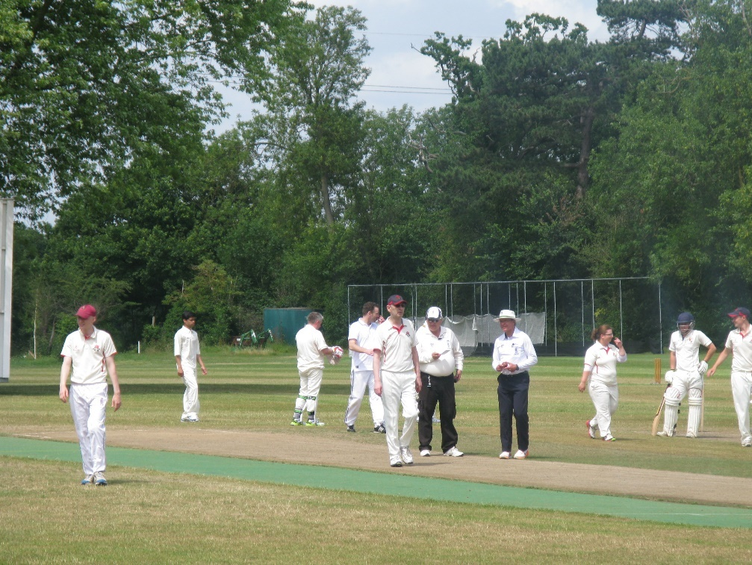

This document is primarily, but not exclusively, intended for use by those in the accreditation programme towards their U3A.
It is not a mandatory part of the programme but is considered a helpful aid as it contains many real-life scenarios that have been encountered by your colleagues over many years.

Thanks to the significant contributions from:
Ian Royle REO South Central Region & CDO Oxfordshire
And the Stage 3 Working Group 2020
Editor
John Golding RDO South Central Region & CDO Berkshire

The intention is that each of the twenty scenarios in this Playbook can be worked through on your own or with your colleagues or your mentor.
There is also space to enter and use five scenarios that you may have come across in your umpiring career to date.
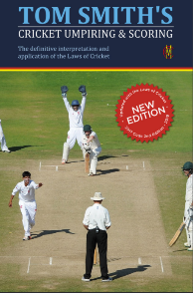
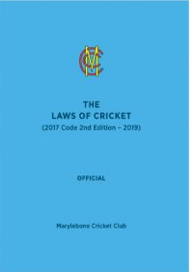
Reference can be made to the latest edition and the MCC Laws of Cricket, Tom Smith's and appropriate local competition regulations.
However, your answers should be along the lines of answering the questions "What would you actually do?" and "How would you handle the situation and what strategies would you employ?"

The rear section of this Playbook contains some useful information sheets and links to various CPD modules that will enhance your experience.

Use the lower box to enter your answer and any comments (max 2250 characters)
Scenario 3.1
You are standing at the bowler’s end.
A legal ball is delivered, and the batsman hits the ball, on the ground, towards the boundary and commences to take a run. A fielder runs after the ball in an effort to stop a boundary 4.
From outside the boundary a dog, runs onto the field of play and stops the ball before the boundary rope.
The batsmen have legally completed 2 runs.
What do you do?
Click or tap here to enter text.

Use the lower box to enter your answer and any comments (max 2250 characters)
Click or tap here to enter text.
Scenario 3.2
You are at the bowlers end in a 50 over win/lose (maximum 10 overs per bowler).
The opening bowler delivers the 1st ball of his 11th over and the batsman is caught in the slips. There is an appeal which you answer in the affirmative.
As the batsman walks off, the scorers bring the matter to your attention.
What now?
Use the lower box to enter your answer and any comments (max 2250 characters)
Scenario 3.3
According to the Regulations your league match has a scheduled start of 1pm
The captains tell you and your colleague that they are ready to start at 1250pm.
What do you tell them?

Click or tap here to enter text.

Use the lower box to enter your answer and any comments (max 2250 characters)
Scenario 3.4
The match that you have been appointed to is your first Royal London U18 County Cup fixture. It has been raining most of the week but it is dry at present. The forecast is for persistent showers.
Explain what you and your colleague should do after your arrival at the ground and prior to the time when you are ready to walk out of the pavilion before the start of the game.
What would you agree/discuss with your colleague?
What are you looking for when carrying out the ground inspection?
What would you agree/discuss with the captains and the scorers?

Click or tap here to enter text.

Use the lower box to enter your answer and any comments (max 2250 characters)
Scenario 3.5
The light starts to fade which concerns you and your colleague.
There are only 5 overs left and a result in sight.
Do you suggest to the fielding captain that if he uses slow bowlers it is OK for play to continue?
OR
The captain says he will only use his slow bowlers.
Do you allow play to continue?

Click or tap here to enter text.

Use the lower box to enter your answer and any comments (max 2250 characters)
Scenario 3.6
You are the striker’s end umpire and standing with a less experienced colleague.
The striker plays a fair delivery towards mid-on with no chance of a run. The non-striker has backed up a few paces but does not return to his ground and starts to do a bit of “gardening” on the pitch, tapping down a few marks. Mid-on picks up the ball and runs into the bowler’s and removes the bails from the wicket with the non-striker still out of his ground and totally oblivious to what is going on. There is an appeal, and your colleague gives the non-striker out.
The striker approaches you and ask you to “Sort out this mess please.”
What would you do on the field? What might you do in any debrief with your colleague after the game?

Click or tap here to enter text.

Use the lower box to enter your answer and any comments (max 2250 characters)
Scenario 3.7
You are a panel appointed umpire and you are suspicious that the bowler at your end has a suspect action, particularly when he puts extra effort into the delivery.
When the ball is dead you approach your colleague, who is associated with the club for whom the bowler plays. You ask him to assist you by watching the bowler’s action. Your colleague declares that the bowler has been checked by the club coach and his action has been cleared.
Explain what action, if any, you should take?

Click or tap here to enter text.

Use the lower box to enter your answer and any comments (max 2250 characters)
Scenario 3.8
You are standing at the Bowlers end, when a bowler, delivered the ball from behind you. You were unable to see the placement of his feet.
The Striker skies a ball from a leg spinner, and it is coming down for a simple catch in the middle of the pitch. The non-striker runs at an angle across the pitch and directly into the back of the bowler (allegedly to be ball watching and have made contact by mistake) who is positioned for the catch. Knocking the bowler to the ground and he fumbles the catch.
An appeal is made.
What is your response?

Were you correct?

What are your actions?

Click or tap here to enter text.

Use the lower box to enter your answer and any comments (max 2250 characters)
Scenario 3.9
A striker deliberately runs short, and your colleague gives him a first and final warning and invokes the appropriate procedures that go with such a warning.
Two overs after the above incident you are standing at the Bowlers End. Following the delivery of a ball you call & signal ‘wide ball’ and the batsmen take runs. During the fielding of the ball the batting partner, who was at the wicket when the warning for the above short run was given, deliberately runs short. What action should you now take?

Click or tap here to enter text.

Use the lower box to enter your answer and any comments (max 2250 characters)
Scenario 3.10
You are umpiring a standard limited over match where the regulations state there must be four fielders within the 30-yard circle.
Just after the bowler delivers the ball with the batsman lining up his shot, the bowlers end umpire calls no ball and the batsman is caught.
Now the fielding captain asks the bowlers end umpire what the no ball was for as the bowler’s front foot was well behind the crease, both bails were still on and it was not a beamer.
The umpire replies that it was because there were only three in the ring. However, the fourth fielder was directly BEHIND him.
What action for the umpires?

Click or tap here to enter text.

Use the lower box to enter your answer and any comments (max 2250 characters)
Scenario 3.11
The match started on time but was interrupted after 28 overs because of rain. The covers were put on. The rain continued for a while and an early tea was called. No decision has yet been made to resume play. During the tea interval, a number of the home team players are on the outfield playing football with cones for goalposts. The play is being supervised by their coach.
What action, if any, would you take?

Click or tap here to enter text.

Use the lower box to enter your answer and any comments (max 2250 characters)
Scenario 3.12
The regulations in a match specify there may be at most 5 fielders outside the ring.
As the bowler delivers the ball, the striker’s end umpire sees that there are only three fielders in the ring and calls no-ball. The fielding captain says that the player had to go off for urgent medical treatment. What do you say?
The captain says that the other player was not fielding, so there were only five out.

Does this make a difference?

Click or tap here to enter text.

Use the lower box to enter your answer and any comments (max 2250 characters)
Scenario 3.13
There is a big appeal for lbw, and the batsmen set off for a run. Just after they cross you raise your finger, and they stop running. Almost immediately you realise you have made a huge mistake, and the batsman had in fact edged the ball onto their pad. What do you do next, and how do you restart the game?
The two batsmen have completed the run.

Does that make any difference?

Click or tap here to enter text.

Use the lower box to enter your answer and any comments (max 2250 characters)
Scenario 3.14
At the toss before the game, away captain calls correctly and says we will have a bat.
All leave the field to get ready,
At 5 minutes before play is due to commence and both teams come out ready to field. The away team Captain then comes over to you and says I said they could bat.
Both you and your colleague agreed you heard him say he would bat.

What do you do?

Click or tap here to enter text.

Use the lower box to enter your answer and any comments (max 2250 characters)
Scenario 3.15
The (ex-county player) striker picks up the ball and hands it to the bowler.
This leads to the wicketkeeper appealing and leaping up and down shouting “he can’t f***ing do that, it’s still our ball”.
What would you do?

Click or tap here to enter text.

Use the lower box to enter your answer and any comments (max 2250 characters)
Scenario 3.16
The visiting team score the winning run off the last ball of their allotted overs. Ten minutes later the scorers tell you there is an error, and the visiting team are four runs short. How do you handle it?
As a supplementary how would the following alter your answer (or would it)?
The visiting captain has already left the ground thinking he has won.
How does that alter your actions?

Click or tap here to enter text.

Use the lower box to enter your answer and any comments (max 2250 characters)
Scenario 3.17
A player has committed a disciplinary offence. You have followed the requirements of Law 42. At the end of the match, you tell the captain you want to see him and the player in five minutes to advise them you are reporting the incident. The captain and player turn up with three colleagues and want to discuss the matter.
How do you manage this?

Click or tap here to enter text.

Use the lower box to enter your answer and any comments (max 2250 characters)
Scenario 3.18
You are at the bowler’s end. A fast bowler is on and the wicketkeeper and slips are standing back. The pavilion is over your right shoulder in the region of long-on.
The bowler oversteps and you call “No Ball”. The striker edges the delivery, and it is caught by first slip. The striker immediately sets off towards the pavilion, obviously believing he has been caught and not having heard the call of “No Ball”. First slip then throws the ball at the stumps at the striker’s end and the wicket is broken with the striker out of his ground.
What would you do?

Click or tap here to enter text.

Use the lower box to enter your answer and any comments (max 2250 characters)
Scenario 3.19
The striker plays the ball out towards long-on and the batsmen amble a single. The fielder throws the ball in to the bowler’s end, but his throw is misdirected.
The striker, now standing in his ground at the bowler’s end, reaches up and catches the ball and returns it to the bowler.
The wicket-keeper appeals.

How do you proceed?

Click or tap here to enter text.

Use the lower box to enter your answer and any comments (max 2250 characters)
Scenario 3.20
It’s a damp day and ground preparation has been delayed. The employed groundsman removes the covers so umpires and captains can inspect the pitch. You are satisfied, having inspected both pitch and outfield, that play can commence at 13:00, 30 minutes late. The toss takes place, and the visitors elect to bowl first. You go back to the umpires’ room to complete your preparations and hear and see the groundsman mowing the pitch.

What do you do now?

Click or tap here to enter text.

The following pages contain two handouts that may be of use to you.
Along with those in the U2A Playbook, a copy of which can be obtained from your County Development or Education Officer.

To help you develop there are a series of online CPD Modules that have been developed by the ACO and various Counties. They are readily accessible by all.
See:
South Central Region CPD Modules

Lancashire ACO CPD Modules
Middlesex ACO Preparation

The Spirit of Cricket
Cricket owes much of its appeal and enjoyment to the fact that it should be played not only according to the Laws but also within the Spirit of Cricket. The major responsibility for ensuring fair play rests with the captains, but extends to all players, match officials and, especially in junior cricket, teachers, coaches, and parents.
Respect is central to the Spirit of Cricket.
Respect your captain, teammates, opponents, and the authority of the umpires.
Play hard and play fair.
Accept the umpire’s decision.
Create a positive atmosphere by your own conduct and encourage others to do likewise.
Show self-discipline, even when things go against you.
Congratulate the opposition on their successes and enjoy those of your own team.
Thank the officials and your opposition at the end of the match, whatever the result.
Cricket is an exciting game that encourages leadership, friendship, and teamwork, which brings together people from different nationalities, cultures and religions, especially when played within the Spirit of Cricket.

Guidelines for Players who Umpire and/or Score.
These guidelines are provided to help ensure that ECB and League regulations are consistently applied in both innings. They should be discussed with the Standing Umpire(s) prior to the toss.

Players who Umpire at the Strikers End
To maximise the match experience, it is recommended that experienced players who know the laws of the game assist the standing umpire by standing at the striker’s end.
The Player is an Umpire and a Partner of the Standing Umpire and is:
- Responsible for stumping and run out decisions (the line needs to be visible to make sure of the grounding behind it).
- Ensuring the stumps and bails are correctly set after the wicket is broken.
- Confirming catches in the field and whether the players crossed before the catch.
- Confirming the ball reaches the boundary bouncing or on the full.
- Counting the valid deliveries in the over and acknowledgment of balls to go signals from the bowler’s end umpire. (Signals are usually made with 2 balls to go in the over)
- Advising of any short runs.
- Advising of any deliveries that pass the batsman on the full above waist height in a standing position.
(the pace of the bowler is not relevant, and the waist is the belly button above the top of the trousers).
- Advising of any delivery that bounces above head height of the batsman in a standing position.
- Confirming the number of completed runs before the ball is dead or if thrown over the boundary by a fielder (the standing umpire will consult in these situations).
- Call no ball when the fielding side has more than two fielders behind square on the leg side or other fielding restriction violations depending on regulations for the match.
- The standing umpire may consult on other issues during the game.

Guidelines for Players who Umpire and/or Score (cont.)

Players who Score.
The scorers are responsible the scores, which must be a minimum of the runs scored, wickets taken, and overs bowled. The umpires will want to be certain that all of their signals have been received so all signals must be acknowledged by a wave or other agreed method and correctly recorded in the scorebook.
The umpires do not keep score.
- Update the scorebook every ball and acknowledge all signals from the umpires.
- Update the scoreboard at least at the end of each over. The number of overs bowled is critical.
- Advise on number of balls left in the over when asked by the umpires.
- Advise on number of overs bowled by each bowler when asked by the umpires. (ECB young player bowling and fielding restrictions apply).
- Be available to confirm the score at the end of each innings, confirming the noted penalty runs and other irregularities that have occurred.
- Record the start and end time of any interruptions in play due to bad weather as this information is required to determine the number of overs lost in the game.

